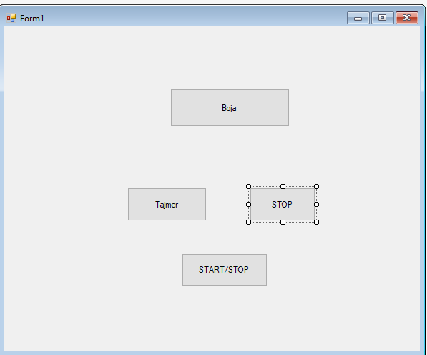

public Form1()

{

InitializeComponent();

}

Random r = new Random();

private void btnBoja_Click(object sender, EventArgs e)

{

//BackColor = Color.Blue;//plava

//int br=r.Next(256);

// BackColor = Color.FromArgb(br, br, br);

BackColor = Color.FromArgb(r.Next(256), r.Next(256), r.Next(256));

//BackColor = Color.FromArgb(0,255, 0);//zelena boja

}

private void timer1_Tick(object sender, EventArgs e)

{

BackColor = Color.FromArgb(r.Next(256), r.Next(256), r.Next(256));

}

private void btnTajmer_Click(object sender, EventArgs e)

{

timer1.Enabled = true;

}

private void btnSTOP_Click(object sender, EventArgs e)

{

timer1.Enabled = false;

}

private void btn_Click(object sender, EventArgs e)

{

timer1.Enabled = !timer1.Enabled;

}

}

}